Work Manager ver1.0

Ho Chi Minh, November 2016

*A - Added M - Modified D - Deleted
Effective Date | Changed Items | A*  M, D | Change Description | New Version
Nov 25, 16 | First release | A |  | 1.0
Nov 29, 16 | Add diagrams | M |  | 1.1

Server
  - Overall Description
    - Overview

Server will provide all feature for admin can storage information about Teams, Members, Work.

Manager program
  - Overall Description
    - Overview
This program will setup on manager computer. Manager can Add teams, members, work…
This program save all data upload to server. Manager just work with this program, do not work directly with server.
    - External interfaces
      - Prototype:
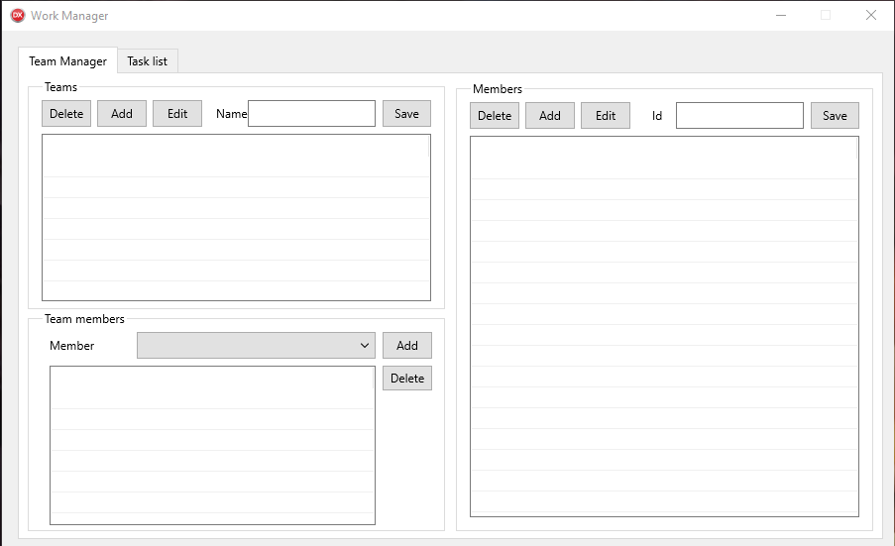

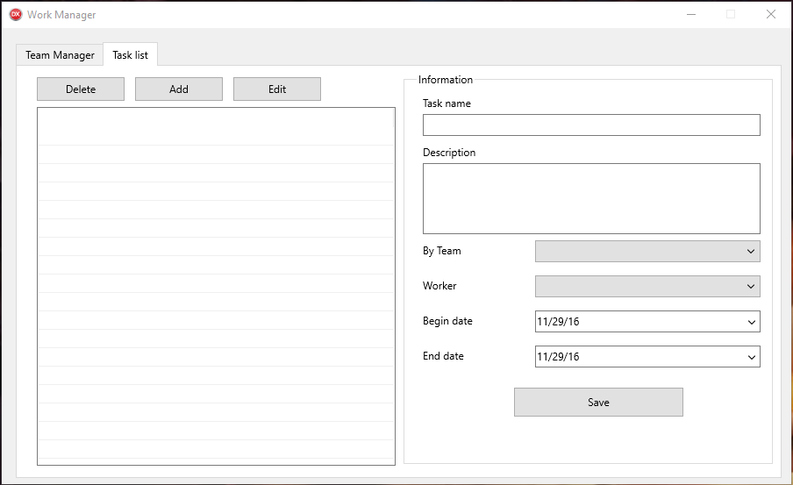
      - Screen description
        - Team Manager
Function:
Teams: Administrator can add, delete, edit Teams.
Team members: Administrator can add, delete, edit Team members.
Members list will get from Members. Admin can add member into Teams.
Members: All member will get from server. Administrator can add, delete, edit Members. It will change from server.
        - Task list
Function:
Information: This field will display all information from selected task contain: Task name, Description…
Left control: All task will get from server. Admin can add, delete, edit selected task.

